Client :

The place where we put the request is a client machine

The web pages will never hold the data , the request is sent to server

The webpages have some code internally , that piece of code takes the request from the user process it , transfer that request to the server.

Note : webpages and servers will never store the data .

The technologies used in the client machine are executed without any dependency on the server . The frontend technologies are executed within the client machine without any third party dependencies

We need a database to fetch the requested data from the user.

But , We can never communicate from client to database directly , because there are no drivers that translate from client to database directly , only the server holds the drivers .

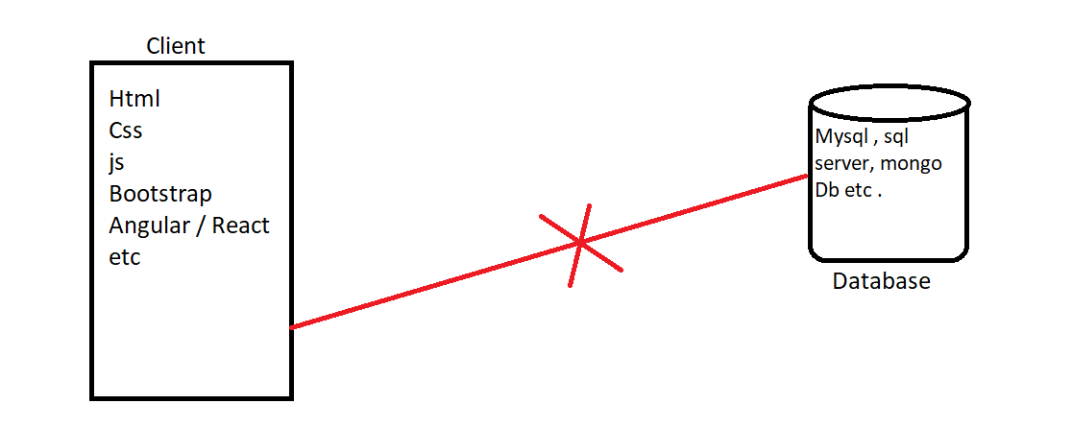

The server holds some backend code along with the drivers

client machine sends the request to the server. Drivers are said to be as translators , the request from the client is translated to the database understandable code , the Database process the request and send the requested data , the Driver again translates the data coming from database to UI understandable code and sends that to the client machine .

( java uses apache tomcat server and drivers used by the server are JDBC , ODBC ).

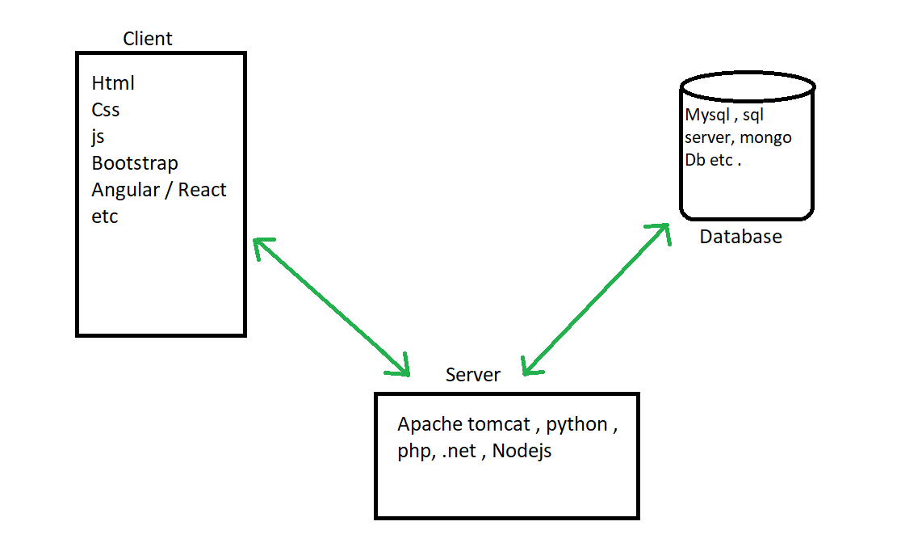

There are different servers Apache tomcat ( java ) , python , php , .net etc . but we can choose any one of our choice .

Html – the content on the web page that you could able to see is only because of html

Css – for the html content we could able to add some beautification (adding colours etc ) is done by css.